Project Design Phase-II
Data Flow Diagram & User Stories

Date | 17 February 2026
Team ID | LVIP2026TMIDSB7385
Project Name | Custom Itineraries for Your Next Journey
Maximum Marks | 4 Marks
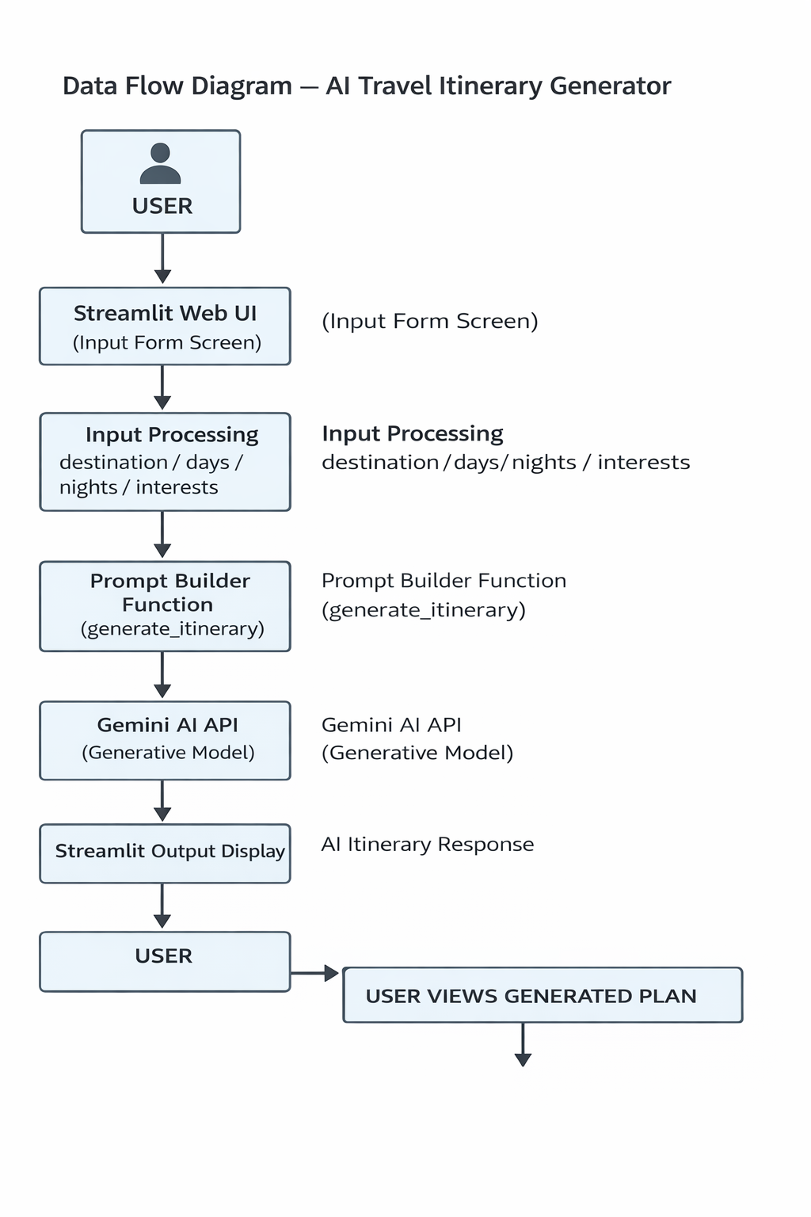
Figure: Data Flow Diagram — AI Travel Itinerary Generator
